Task 3:
Demonstrate data analysis skills using Pandas.
Code:
In file analysis.py
import pandas as pd

df = pd.read_csv(r"C:\Users\shobh\OneDrive\Desktop\pandas-data-analysis\data.csv")

print(df)
print("\nFirst 5 Rows:")
print(df.head())
print("\nDataset Info:")
print(df.info())

it_employees = df[df["Department"] == "IT"]

print("\nIT Employees:")
print(it_employees)

average_salary = df.groupby("Department")["Salary"].mean()

print("\nAverage Salary by Department:")
print(average_salary)

In file data.cvs
Name,Department,Salary,Experience
Ravi,IT,50000,2
Sita,HR,45000,3
Kiran,IT,52000,4
Anu,Finance,55000,5
Raj,HR,40000,2

Code: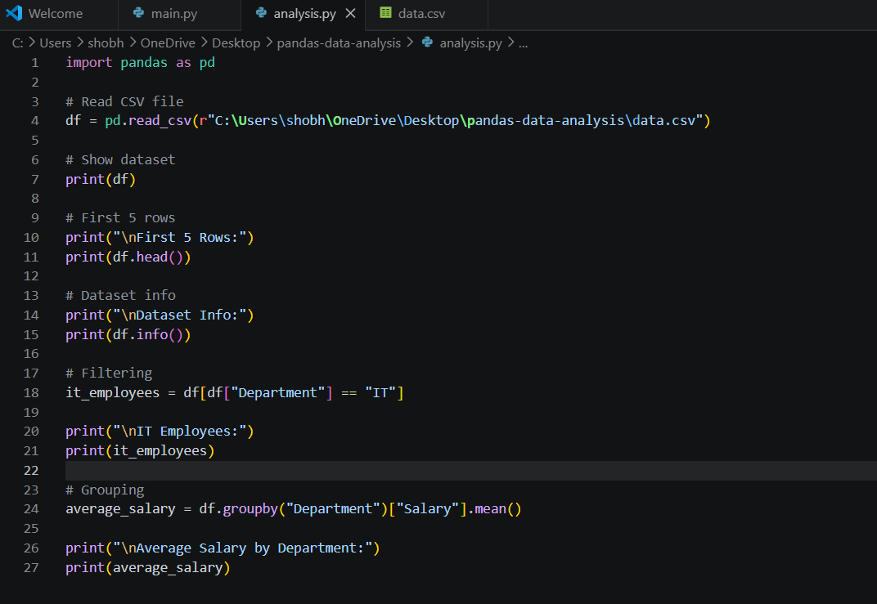

Another file:
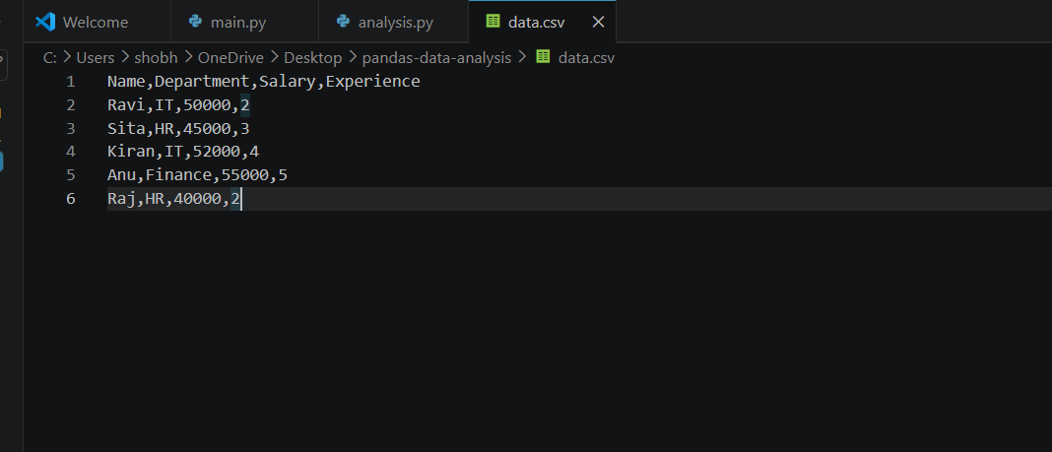

Output:
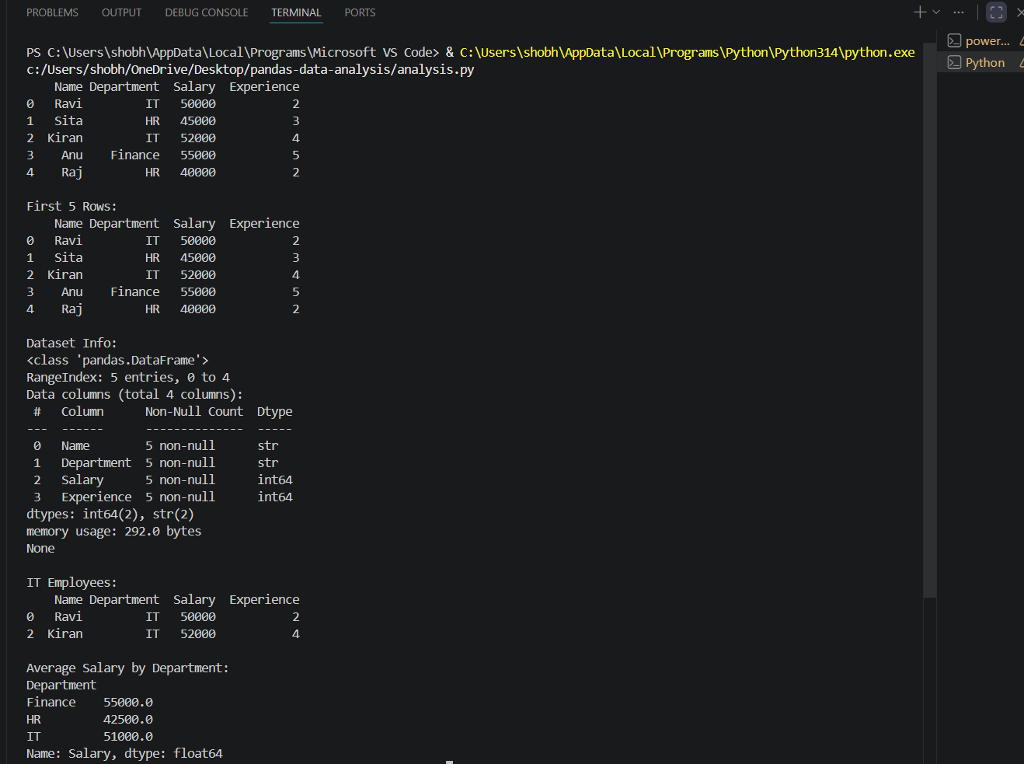
Code snippets:
- Import Pandas
import pandas as pd
- Load CSV Dataset
df = pd.read_csv(r"C:\Users\shobh\OneDrive\Desktop\pandas-data-analysis\data.csv")
- Inspect Dataset
print(df)
print(df.head())
print(df.info())
- Clean Incorrect Data
df["Salary"] = pd.to_numeric(df["Salary"], errors="coerce")
Fill Missing Values
average_salary = df["Salary"].mean()
df["Salary"].fillna(average_salary, inplace=True)
- Filtering Data
it_employees = df[df["Department"] == "IT"]
print(it_employees)
- Grouping and Aggregation
department_salary = df.groupby("Department")["Salary"].mean()
print(department_salary)
hosted link: https://gist.github.com/shobhanabathina/19fbe0a7592e018ec92784e47a299ae3

github repo link: https://github.com/shobhanabathina/Alfido_tech-python.git

